MOHANA SILK E-COMMERCE PROJECT PLAN

COLOR PALETTE:

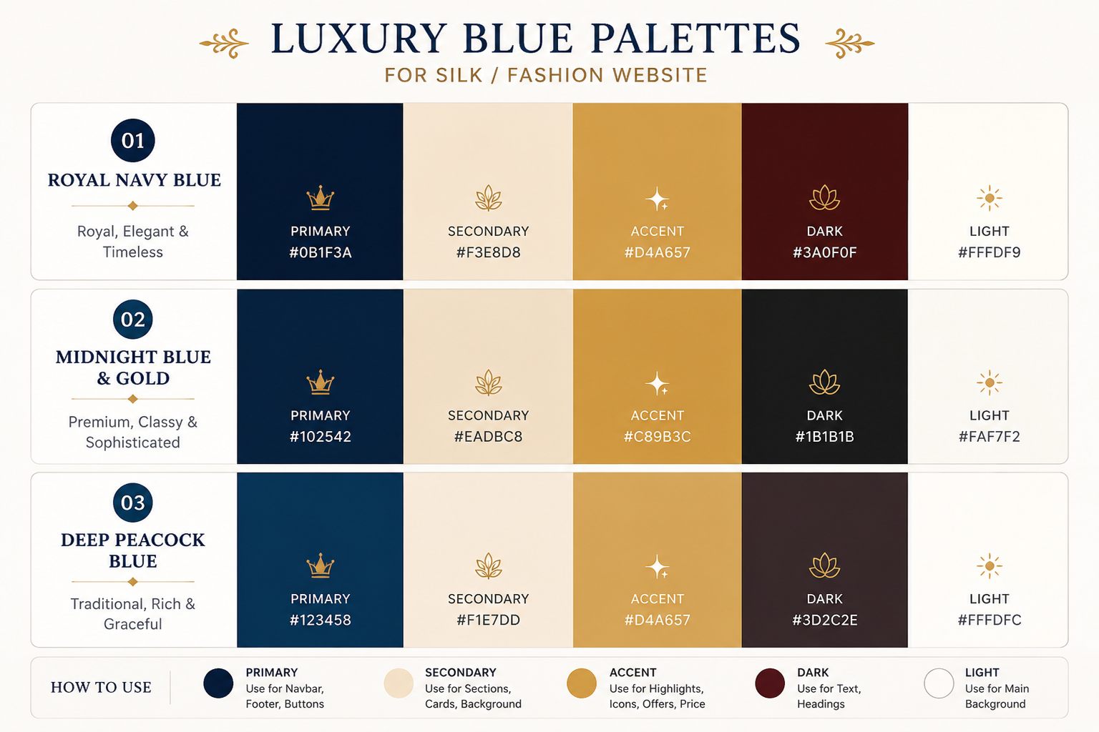
- Primary - #0B1F3A
- Secondary - #F3E8D8
- Accent - #D4A657
- Dark - #3A0F0F
- Light - #FFFDF9

PROJECT OVERVIEW:

Mohana Silk is a luxury silk saree e-commerce website project designed to provide users with a modern, elegant and user-friendly shopping experience for traditional and contemporary sarees.

The website focuses on:
- smooth navigation
- premium visual design
- product categorization
- saree exchange offers
- new arrivals
- price-based shopping
- responsive user interface

The project is inspired by existing saree websites such as Nalli, Madras Sarees and other premium ethnic fashion platforms while maintaining its own unique identity and layout structure.

PROJECT OBJECTIVE:

The objective of this project is to develop a responsive and visually appealing silk saree e-commerce platform that allows users to easily explore saree collections, view offers, shop based on categories and pricing, and interact with the brand through a premium digital experience.

TARGET USERS:

- Women shopping for silk sarees
- Bridal saree buyers
- Festival and occasion shoppers
- Traditional wear customers
- Users searching for sarees within specific budgets
- Customers interested in saree exchange offers

WEBSITE FEATURES:

1. Sticky Navigation Header
2. Hero Banner Carousel
3. Product Categories Section
4. Price Range Shopping Section
5. New Arrivals Section
6. Saree Exchange Offer Section
7. Featured Collections
8. Wishlist and Cart
9. Responsive Product Cards
10. Large Informative Footer
11. Social Media Integration
12. WhatsApp Contact Support
13. Search Functionality
14. Smooth Scrolling Experience

WEBSITE FLOW:

1. Header Section
2. Hero Banner Carousel
3. Categories Section
4. Featured Collections
5. Price Range Section
6. New Arrivals Section
7. Saree Exchange Offer Banner
8. Promotional Sections
9. Footer Section

HEADER CONTENT:

- Website Logo
- Categories
- New Arrivals
- Saree Exchange
- Wishlist
- Shopping Cart
- Search Bar
- User Profile/Login

HERO SECTION DETAILS:

The hero carousel banner will contain promotional slides such as:
- Today's Deals
- Wedding Silk Collection
- Casual Wear Offers
- Exchange Your Old Saree
- Festival Offers
- Seasonal Discounts
- Premium Silk Promotions

The carousel will automatically slide and also support manual navigation.

DESIGN STYLE:

The website follows a luxury and elegant design approach inspired by premium silk saree brands.

Design characteristics include:
- clean layouts
- premium typography
- soft shadows
- spacious sections
- cream/light backgrounds
- navy blue and gold color accents
- modern responsive UI

TYPOGRAPHY:

Heading Font:
- Playfair Display

Body Font:
- Poppins

The typography combination is selected to create a premium and elegant fashion website appearance.

TECHNOLOGIES USED:

Frontend:
- HTML5
- CSS3
- JavaScript

Future Enhancements:
- React.js
- Firebase / Backend Integration
- Payment Gateway
- Database Integration

FUTURE ENHANCEMENTS:

- User Authentication
- Online Payments
- Order Tracking
- AI-Based Recommendations
- Dark Mode
- Mobile Application
- Admin Dashboard
- Product Filtering
- Customer Reviews

SPECIAL FEATURE:

The website includes a dedicated Saree Exchange Offer section where customers can exchange eligible old sarees and receive offers or discounts on new purchases.

UI/UX INSPIRATION:

The project UI inspiration is taken from:
- Nalli
- Madras Sarees
- Other modern ethnic fashion e-commerce websites

The goal is to combine luxury aesthetics with smooth user experience and simplified shopping navigation.

PERSONAL NOTE:

This project is being developed as a frontend web development practice project focused on improving UI/UX design skills, responsive layout structuring and modern e-commerce website development concepts.

